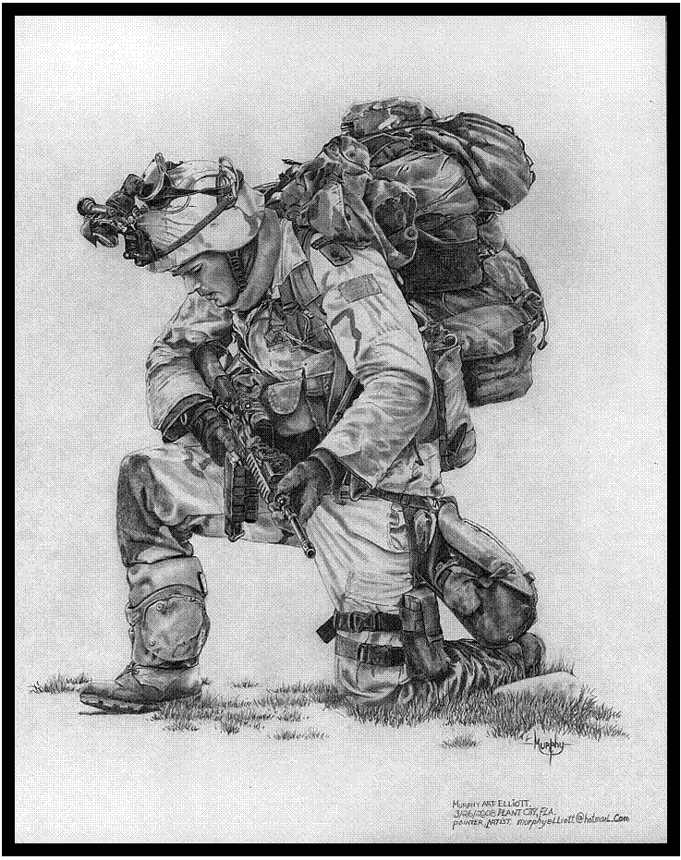

National Day of Prayer for Defence

2025

National Day of Prayer for Defence
Sponsored by Military Christian Fellowship of Australia
http://mcf-a.org.au

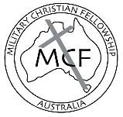
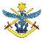

Contents
Welcome ................................................................ 2
The Lord’s Prayer ................................................. 2
Order of Events ..................................................... 3
Scripture ................................................................ 4
Thanksgiving ......................................................... 5
Prayers .................................................................. 6

Prayer Focus 1: .................................................... 7
Defence Health and Wellbeing, Faith Under fire, Christian Defence events

Prayer Focus 2: .................................................... 8
Deployed Personnel, Defence Members and families

Prayer Focus 3: .................................................... 9
Senior Leadership, Defence Culture and Training Settings

Prayer Focus 4: .................................................... 10
ADF Chaplaincy and Defence Christian Ministries

Prayer Focus 5: .................................................... 14
Local Needs

Prayer for Defence ................................................. 15

Welcome
Welcome to the National Day of Prayer for Defence, which has been running for over 10 years. We appreciate your commitment in giving your time to pray for the Australian Defence Force, for Defence members, families, leaders, and government. All of us need prayer to give us wisdom and strength to make the right decisions to guide our nation into the future. Defence Christian military ministry members as well as Christian Chaplains and those who have a heart for Defence from across Australia will be using this structure at some time this year to be a part of this important activity. Jesus demonstrated a regular and passionate prayer life, sometimes publicly and sometimes alone. He also prayed at critical moments in his life. He gave a simple but powerful example of how to pray with The Lord’s Prayer (Luke 11:1).

THE LORD’S PRAYER
Our Father, who is in heaven,
hallowed be your Name.
Your Kingdom come,
your will be done on earth,
as it is in heaven.
Give us this day our daily bread
and forgive us our sins,
as we forgive those who sin against us.
Lead us not into temptation,
but deliver us from evil.
For yours is the kingdom,
the power, and the glory,
for ever and ever.
Amen.

Order of Events (To be developed by regional contact or organiser)
Adjust the content of this booklet to suit your group. We don’t mind what you change. Also remember to adjust the contents page when your content has been added. Either pray through the elements together or break up into small groups.

Please change people and photos in ‘Senior Leadership’ section as required, especially check it’s correct if there has been a Federal election.

Songs
The facilitator may include songs if appropriate.

SCRIPTURES (selection of verses below or choose others)

1 John 5:14-15 (NRSV)
And this is the boldness we have in him, that if we ask anything according to his will, he hears us. And if we know that he hears us in whatever we ask, we know that we have obtained the requests made of him.

Ephesians 6:18 (NIV)
And pray in the Spirit on all occasions with all kinds of prayers and requests. With this in mind, be alert and always keep on praying for all the Lord’s people.

1 Timothy 2:1-2 (ESV)
First of all, then, I urge that supplications, prayers, intercessions, and thanksgivings be made for all people, for kings and all who are in high positions, that we may lead a peaceful and quiet life, godly and dignified in every way.

Philippians 4:6-7 (NIV)
Do not be anxious about anything, but in every situation, by prayer and petition, with thanksgiving, present your requests to God. And the peace of God, which transcends all understanding, will guard your hearts and your minds in Christ Jesus.

THANKSGIVING

Almighty God, in your wisdom you so ordered our earthly life
that we must walk by faith and not by sight: give us such trust in your care, that in the face of all challenges we may give proof of our faith by the courage of our lives; through Jesus Christ our Lord. Amen.
- Thank you for your Son Jesus Christ the Lord, for his sacrificial life.
- Thank you for God’s great mercy upon our nation.
- Thank you for raising righteous godly people in positions of influence in Defence, especially, for MAJGEN Sue Graham, as the Patron of Military Christian Fellowship of Australia.
- Thank you for ADF Christian Chaplaincy and the wonderful work that they do as Christ’s ambassadors in Defence.
- Thank you that spiritual matters are valued by Defence.
- Thank you for the Defence Faith under Fire Course and other Christian material for Defence, like ADF Bibles and devotionals. Thankyou for lives changed and transformed.
- Thank you for Defence Christians who are growing in discipleship and standing strong in their faith.
- Thank you for the valour & courage of the troops in operations at home and abroad.
- Thank you for the marriages and families of service personnel.
- Thank you for the relationships between service men and women, whether junior or senior staff, that God has reconciled or brought in peace where it is needed.
- Thankyou for the guidance of the Holy Spirit in deepening faith and growing godly lives of integrity that multiply God’s grace.
PRAYERS

The NAVAL Prayer
Eternal God, creator of the heavens and ruler of the raging seas, take under your powerful protection and bless all members of the Royal Australian Navy. Preserve them from the dangers of the sea and strengthen them so that they may faithfully serve our country. With the help of others who love freedom may they be able to ensure security for all those who lawfully travel the seven seas, and by their effort maintain for all people the possibility of serving you in peace and justice all through their lives. We ask this through Jesus Christ, our Lord. Amen.

The SOLDIER’S Prayer
Almighty God, whose command is over all, and whose love never fails, let me be aware of your presence, and obedient to your will. Help me to accept my share of responsibility with a strong heart and cheerful mind. Make me considerate of those with whom I live and work, and faithful to the duties my country has entrusted to me. Let my uniform remind me daily of the traditions of the Service in which I serve. When I am inclined to doubt, strengthen my faith. When I am tempted to sin, help me to resist. When I fail, give me the courage to try again. Guide me with the light of your truth and keep before me the life and example of Jesus in whose name I pray. Amen.

The RAAF Prayer
O Lord who has given us dominion over earth, air and sea. Look upon Your servants and our families who are called to serve our country in the Royal Australian Air Force. Give us courage, a steady nerve and ready mind. Sustain us in days of preparation, in the daily routine servicing and weary waiting. Be with us in time of sudden peril and grant that under Your mighty protection we may be preserved in body, soul and mind. We ask this through Jesus Christ our Lord. Amen.

A Prayer Book For Australia, 1999, the Anglican Church of Australia, Broughton Books, Mulgrave, Vic, p. 591.
Prayer FOCUS 1: Defence Health and Wellbeing and Chaplaincy

PTSD, depression and moral injury are having a severe effect on the lives of many Defence members, families and friends.

Please pray for:

Support for those who are suffering the wounds of service.

People affected to seek appropriate help.

That appropriate assistance will be provided by the chain of command, professionals and their social networks

That they would find the mental healing they require and the spiritual healing that they can know in Christ.

Those who are close to someone going through such struggles: that they would be a wise and loving support, and also would find support themselves.

That the spiritual side of a person’s wellness and mental health will continue to be increasingly recognised by defence and official support provided for the whole person.

Defence Chaplains, health practitioners and others who are in key roles to help members through such difficulties.

Pray that God will use even the darkest of times to bring glory to himself by drawing many to follow him.

ADF Chaplaincy

• Pray for ADF Christian Chaplains that they will be Christ’s ambassadors in Defence and that they will be able to exercise the spiritual component of their responsibilities well.

• Pray that they will be a good witness to the faith and that Defence leadership will continue to value the vital role Chaplains’ play.

• Pray for Christian and all Chaplains as they work in an increasingly complex space with dealing with a multi-faith environment and an increasingly secular Defence culture. Pray that they will be gracious, faithful and wise in the way they approach this.

Prayer FOCUS 2:

Deployed Personnel, Defence members and families
- Pray that Defence members will carry out their responsibilities well.
- Pray for the protection of deployed service men and women.
- Pray for the families of Defence personnel, especially those who are currently deployed or on long exercises.
- Pray for strong marriages pre, during and post deployment.
- Pray that Churches and Defence Ministries would be a great support to families when their loved one is deployed, and when they return.
- Pray for returned service men and women who are coping with physical, emotional and spiritual injuries.
- Pray for their well-being, for healing and wholeness.
- Pray that service men and women, and all Defence members, will fulfil their God given purpose.

Australian Defence Force personnel are deployed to at least 22 operations overseas and within Australia to protect Australia and its national interests. There are a number on peacekeeping or observing missions as well. (http://www.defence.gov.au/operations)

Operation Location

Accordion Middle East Region
Aslan Sudan
Manitou Middle East Region
Mazurka Egypt
Kudu UK
Paladin Israel
Regional Presence Deployments - SW Pacific
Indo-Pacific Endeavour - Indo-Pacific Region
Argos North East Asia
Domestic Operations
Dyurra
Gateway
Linesman South Korea Hydranth Red Sea
Southern Discovery Antarctic
Steadfast Iraq
Augury Middle East
Beech Middle East
Fortitude Syria
Peacekeeping, observing and overseas postings

Prayer FOCUS 3:
Senior Leadership, Defence Culture and Training Settings

Senior Leadership

Minister for Defence Secretary Chief of Defence
the Hon of Defence Admiral
Richard Marles MP Greg Moriarty David Johnston
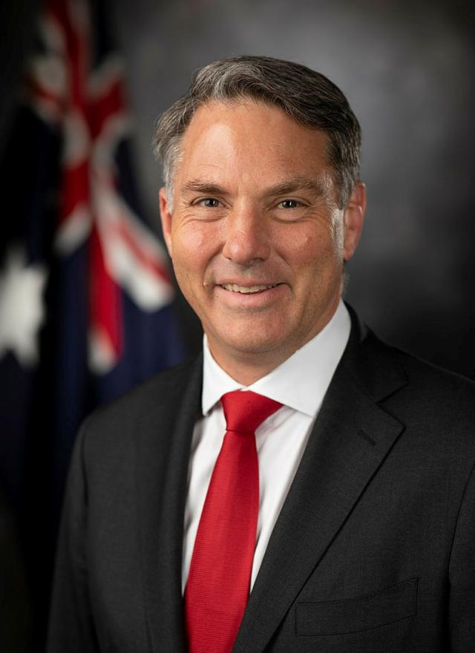
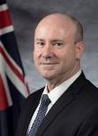
AO, RAN
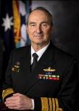

Chief of Navy Chief of Army Chief of Air Force
Vice Admiral Lieutenant General Air Marshal
Mark Hammond Simon Stuart Stephen Chappell
AM, RAN AO, DSC DSC, CSC, OAM
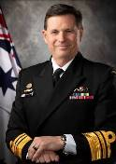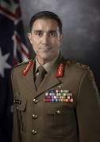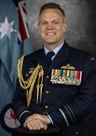

Defence Culture
- Pray that Defence culture would be based on Christian values.
- Pray that Defence continues to monitor Defence members’ behaviour against these values with accountability for their actions.
- Pray that those who have been adversely affected by poor behaviour in the military will find support and closure.

Training Settings
- Pray for the instructional staff, students and families.
- Pray for wisdom to deal with difficult situations.
- Pray that Christian military ministries and Christian Chaplains operating with the training institutions will be successful in bringing the Word of God to the trainees.
- Pray that the trainees will be open to hearing the gospel and acting on it.

Changes in Defence
- Pray for planning and integration of the Defence Enterprise Resource Planning (ERP) program. Pray that each ‘tranche’ will go smoothly as the parts of the ERP program are rolled out over the coming years. Pray for MAJGEN Sue Graham and the other Executives as they oversee this project, and for all others involved.

Prayer FOCUS 4: Defence Christian Ministries

King of Heaven, we lift up to you all the Christian military ministries, particularly those working in the training institutions. Enable them to work in unity and one accord so that your Kingdom may be advanced on earth; may your peace and love be able to enfold the trainees to whom they are ministering. We pray that the trainees will be open to hearing the Gospel message and that it will cut through the noise created by multi-faith and secular attitudes. Be with all staff of these ministries giving them strength, wisdom and grace while serving you. Amen

Forum of Christian Military Ministries (FCMM) and other ministries
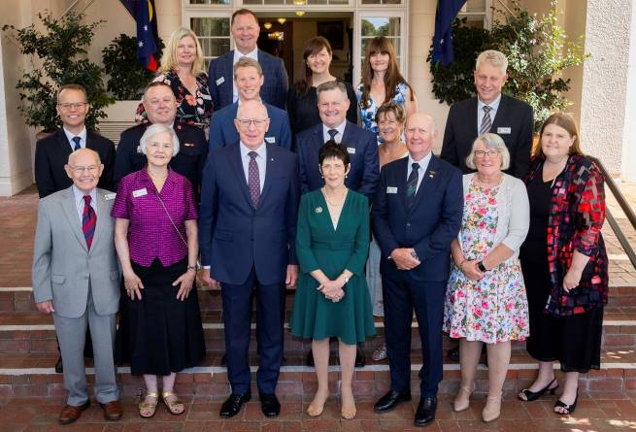
FCMM leads and their spouse, March 2024: Back top – Jamie Van Heel (and Jo) AMCF, Tina King and Helen Mudge Bible Society. Middle – Thomas Bielenberg Navigators, Brett Gallagher RSDS, James Leitch FOCUS, Ken Matthews (and Helen) Everymans, Phil McMaster Solid Rock/Navs. Front – Russell and Helen Bielenberg ACCTS, His Excellency the Governor General David Hurley (past MCF-A Patron) and Mrs Hurley (current Solid Rock Patron), Steve Neuhaus (and Cath) MCF-A, Julianne McMaster Solid Rock. (Sybille Bouzanquet is now Solid Rock lead)

Association for Christian Conferences, Teaching and Service (ACCTS)
- Pray for those involved in ACCTS as they seek to support military Christian leaders to form and develop locally led Military Christian Fellowships around the world, especially for the new Executive Director, CAPT (USN, Ret.) Terry Wichert and his wife Susan as they guide and support their team and seek out new staff.
- Pray that God would raise up a couple with the vision to replace Russell and Helen Bielenberg in continuing this ministry in our region.

Association of Military Christian Fellowships (AMCF)
- Thank God that 8 delegates from the Pacific were able to attend the AMCF Word Conference in Brazil from 15-20 Oct 24.
- Pray that MCF Pacific leaders who attended the AMCF World Conference from Timor Leste, Fiji and Tonga will be able to implement what they were taught to grow their MCF’s.
- Pray for the AMCF Vice President LTCOL Jamie van Heel as he plans to visit Timor Leste in June and Fiji / Tonga in November.
- Pray that the leadership teams in 12 SW Pacific Islands would be encouraged to proclaim the gospel to their military, police and security forces.

Everyman’s Welfare Services
- For opportunities to glorify God’s name and see His kingdom extended through the ministry.
- For God’s wisdom to navigate the road ahead with the upcoming, somewhat expected changes.
- For God’s continued provision to flow freely that we can advance in all areas of need.
- For God’s protection over each member of EWS and board, and to clearly hear and obey His leading.
- For all to experience His peace, His presence, and His power in greater levels, that ADF personnel will recognise a true difference.

FOCUS Military Ministry
- Thank God for His sovereignty and goodness in which we can rest
- Thank God for sending Jesus into this world to rescue us from the punishment our sins deserve
- Pray for the many trainees joining the ADF each year, that they might have the opportunity to hear the good news of Jesus and respond in repentance and faith
- Pray for Christian trainees to grow in their conviction of the gospel and courage to stand firm for Christ

Military Christian Fellowship of Australia
- Pray that more people will come forward to be MCF-A Reps and lead groups at Defence locations across Australia. Thank God for firm and faithful servants who have volunteered in these and all MCF-A roles in the past.
- Pray for the Exec, Council, Staff Worker and Patron – MAJGEN Sue Graham. Pray they will be wise and good stewards in their support of all Christians in Defence. Pray that through MCF-A more people will come into God’s Kingdom.
- Pray for MCFs across the world, especially those in countries where people can be persecuted for being a Christian. Pray for courage and safety and that all Christians across the world will be the salt and light in their sphere of influence.

Navigators Military Ministry
- Praise that Andrew Oldfield is increasing his days with Navigators at ADFA. Pray for others to labourer into the ADF harvest field - Mt 9:35-38, Please pray for perseverance and God’s wisdom – Phil 1:9-11.
- For non-Christians in discipleship to believe in the gospel and follow Jesus as Lord and Saviour.
- For Christians to shine the light of the gospel for God’s glory to their friends and colleagues so God's kingdom expands.
- That we can disciple young men and women to know Jesus better and so they can disciple others.
- Pray that workers in the harvest would have a generational mindset (passing on what has been learnt) 2 Tim 2:2 and ask God for many to hear the word, believe and obey.
- Praise for the growth in numbers and maturity of those involved, and for friends to invite their mates to know Jesus. That we can present them mature in Christ. Col 1:28-29.

Red Shield Defence Services
- Thank God for new opportunities that are presenting themselves.
- Pray that the RSDS practical ministry in supporting members will be something that not only speaks of the love of Jesus, but shows Defence members that they are deeply loved by God.
- Pray for strength for the team with a very busy year ahead.

Solid Rock Ministries
- Praise God for Solid Rock groups that meet
around Australia.
- Pray that more Solid Rock groups will start enabling even more women within the Defence community to connect and support each other.
- Pray that the women would be encouraged in their walk with
Jesus while they continue to grow in community with one another.

Prayer FOCUS 5: Local Needs and other prayer points

Chaplain to Federal Parliament - Leon Hribar
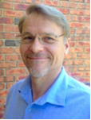
Pray for the Chaplain to Federal Parliament, Leon Hribar, for wisdom and insight needed to support parliamentarians and many others who work in that complex environment. Pray that he would faithfully serve all, regardless of party, ideology or denomination.

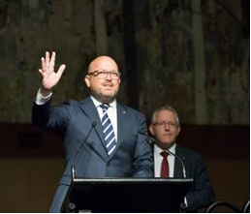
Please pray for God’s blessing on planned initiatives to increase opportunities for Members & Senators to find encouragement in faith across political & denominational lines. Pray also for more churches and organisations across Australia to partner with the Parliamentary Christian Fellowship in these initiatives.

(Senator Matt O’Sullivan (front) and Mr David Smith MP)
Please pray for the Co-Chairs of the Parliamentary Christian Fellowship, Mr David Smith MP and Senator Matt O’Sullivan, and praise God for all their joint efforts which bring honour to Christ’s name in such a complex and demanding workplace.

Feel free to list local prayer needs here, to be customised by the local contact.

PRAYER for defence

Almighty God, we thank You that You are continually moving through the hearts and minds of those who serve you and serve Australia in the Defence Department.

We lift up our hearts to You seeking Your forgiveness for those that we have wronged in thought or deed, we pray that through Your life giving and redeeming blood that You heal us and renew our spirits, enabling us to work with those around us in harmony and peace.

We pray for all who serve in Defence, give them moral and physical courage, comfort in danger, patience in waiting and discipline in performing their duties when deployed overseas or on Domestic Operations, or in their usual place of work. Give them an attitude of service, a heart of compassion and a spirit of peace.

All these we beseech through Jesus Christ our Lord and Saviour.

Amen

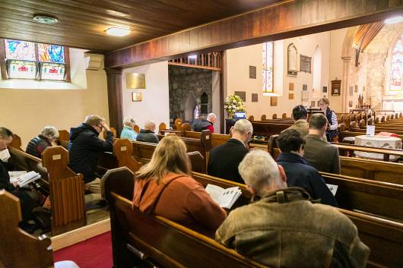

National Day of Prayer for Defence

Sponsored by Military Christian Fellowship of Australia
http://www.mcf-a.org.au

Supporting and building the Kingdom of God in Defence

