With Compliments,

 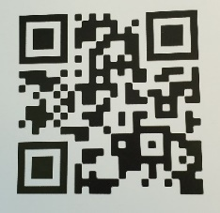

**MCF meets every Thursday 1140**

**LWB-01-074**

Have a Blessed Day!

Have a Blessed Day!

 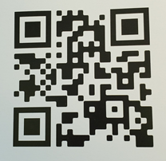

**MCF meets every Thursday 1140**

**LWB-01-074**

With Compliments,