**Media Release**

**National Day of Prayer & Fasting Sat 26 February 2022 Again Indigenous Christian Leaders Play a Key Role**

The National Day of Prayer & Fasting will be held on **Saturday 26th February 2022**. The theme for 2022 is “**PURITY IN CHRIST.**” The scriptural theme is found in Psalms 51:10, “***Create in me a pure heart O God, and renew a steadfast spirit within me.***”

There is great power in unified prayer. Psalm 133 says, “***When brethren dwell together in unity… there the Lord commands a blessing even life for evermore.***”

The primary goal of the National Day of Prayer & Fasting is to Glorify God!

* Our prayer focus is to see individuals, our churches and our nation experience an outpouring of the Holy Spirit as it says in Acts 2: 17,21. “***I will pour out my Spirit on all people… And everyone who calls on the name of the LORD will be saved.*** “
* Our central prayer remains the same: that Australia will experience Revival, Reformation & Transformation and millions will come to Christ.
* Our personal prayer is that our friends and family members will find Jesus, and all our churches will thrive and grow. We are also praying in particular for a new generation of young prayer warriors and young evangelists to arise.
* Our overarching objective is that through our prayers on the day all Australians will be blessed and prosper, whether they be people of faith or no faith, or peoples of other faith. The scripture (Genesis 22:18) is right to say through you, ‘***all the Nations of the earth will be blessed.***’
* The National Day of Prayer & Fasting is not just about us as believers, but about the wellbeing and betterment of Australia. It is our Christian opportunity to pray for our Parliamentary leaders, National Leaders & Church leaders, as well as the ongoing safety and prosperity of our nation. The National Day of Prayer & Fasting is ultimately all about the greater good of all.

Our core scripture is found in 2 Chronicles 7:14 ~ “***If My people, who are called by My name, will humble themselves and pray and seek My face and turn from their wicked ways, then I will hear from heaven, and I will forgive their sin and will heal their land.***”

**Indigenous Christian Leaders Play a Key Role in Leading the Day**

This year, in light of last year’s success, the National Day of Prayer & Fasting team has again asked Indigenous Christian Leaders to help lead the day. This decision was also inspired by the success of Ps Peter Walker’s (pictured) very historic Indigenous led [National Solemn Assembly](https://www.nationaldayofprayer.org.au/solemn-assembly/) on 26-27 September 2020. Watch [Day One here](https://youtu.be/rQ2ZvBz-Aig), and [Day Two here](https://youtu.be/yutsgy7Wo5s).

We invite you to join us on the National Zoom Prayer Call anytime between **9AM – 6PM (AEDT) Saturday 26 February 2022** or organise your own local combined church celebration in your area as your COVID regulations allow. In particular, we invite you to take part in the **Official Prayer Service from 2PM – 3:30PM (AEDT)** as part of the National Zoom Prayer Call, in which we will have prayers and input from Key National leaders and Church leaders.

We encourage the various venues in each state to stick to the 10AM – 4PM times, if possible, for the combined prayer meetings irrespective of your time Zone. This will allow most of us to be together from all over Australia and allow those groups to tune into the live webcast when the want and as they are able. The 6-hour time slots encourages multi church participation as each church can take an hour or three churches can take two hours each.

In the light of the COVID challenges many will join the National Day of Prayer & Fasting Live Zoom call or Prayer Webcast on YouTube. Others will join us as they are able from the many larger combined church prayer meetings. Other will also join us from smaller church prayer meeting and others in their homes. We encourage each participant to register to receive regular prayer updates and Zoom login information. Make history yourself by joining us in prayer. [Register here.](https://www.nationaldayofprayer.org.au/register-national-day-of-prayer-fasting-2021/)

We would love your help to organise regional inter-church collaborations of the National Day of Prayer & Fasting. Please confirm your interest to help when you [register.](https://www.nationaldayofprayer.org.au/register-national-day-of-prayer-fasting-2021/)

James Condon Chairman NDOPF: Mobile – 0478301468

Wesley Leake NDOPF: 0457288872  
Ps Peter Walker Indigenous Elder: Mobile – 0472512040  
Ps Tim Edwards Indigenous Elder: Mobile – 0439386671

Website: [www.nationaldayofprayer.org.au](https://www.nationaldayofprayer.org.au) Video Promo: <https://youtu.be/L8u7Lmx9L08>

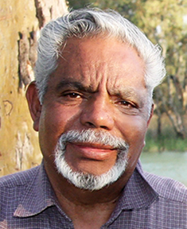 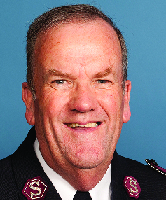 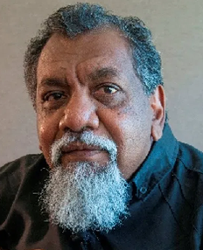

Ps Peter Walker, Indigenous Elder NSW James Condon, Chairman NDOPF Ps Tim Edwards, Indigenous Elder, Qld