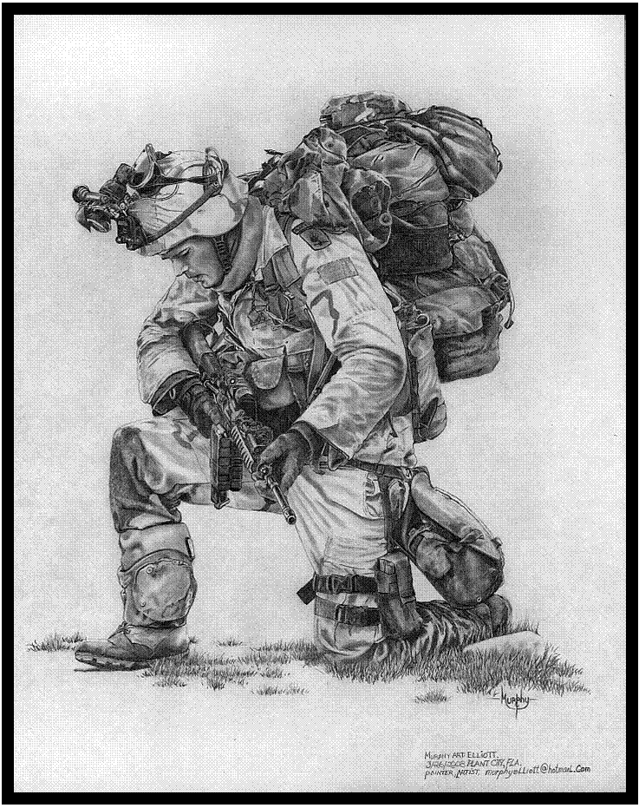

National Day of Prayer for Defence

28 – 29 March 2020

National Day of Prayer for Defence

Sponsored by Military Christian Fellowship of Australia

<http://mcf-a.org.au/>

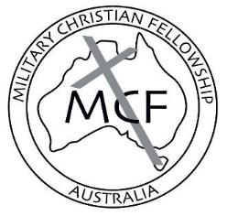

Join us at <http://zoom.us/j/8359803354>

  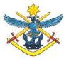

# Contents

Contents 1

Welcome 2

The Lord’s Prayer 2

Order of Events 3

Scriptures 4

Thanksgiving 5

Defence Force Prayers 6

Prayer Focus 1: 7

Prayer Focus 2: 8

Prayer Focus 3: 9

Prayer Focus 4: 10

Prayer Focus 5: 12

Prayer For Defence Reconciliation 13

# Welcome

Welcome to the 10th *National Day of Prayer for Defence*. We appreciate your commitment in giving your time to pray for the Australian Defence Force, for Defence members, families, leaders, and government. All of us need prayer to give us wisdom and strength to make the right decisions to guide our nation into the future. Defence Christian military ministry members as well as Chaplains and those who have a heart for Defence are joining with you at this time around Australia to be a part of this important activity. Jesus demonstrated a regular and passionate prayer life, sometimes publicly and sometimes alone. He also prayed at critical moments in his life. He gave a simple but powerful example of how to pray with *The Lord’s Prayer* (Matthew 6:9-13).

# The Lord’s Prayer

Our Father, who is in heaven,   
hallowed be your Name.  
Your Kingdom come,   
your will be done on earth,   
as it is in heaven.  
Give us this day our daily bread   
and forgive us our sins,   
as we forgive those who sin against us.   
Lead us not into temptation,   
but deliver us from evil.   
For yours is the kingdom,   
the power, and the glory,   
for ever and ever.   
Amen.

# Order of Events

Welcome

Open in Prayer

Scriptures

Break out to pray for different prayer focus areas (~20mins)

Close in prayer

Open Prayer (optional)

# Scriptures

### 1 John 5:14-15 (NRSV)

And this is the boldness we have in Him, that if we ask anything according to His will, He hears us. And if we know that He hears us in whatever we ask, we know that we have obtained the requests made of Him.

### Ephesians 6:18 (NIV)

And pray in the Spirit on all occasions with all kinds of prayers and requests. With this in mind, be alert and always keep on praying for all the Lord’s people.

### 1 Timothy 2:1-2 (ESV)

First of all, then, I urge that supplications, prayers, intercessions, and thanksgivings be made for all people, for kings and all who are in high positions, that we may lead a peaceful and quiet life, godly and dignified in every way.

### Philippians 4:6-7 (NIV)

Do not be anxious about anything, but in every situation, by prayer and petition, with thanksgiving, present your requests to God. And the peace of God, which transcends all understanding, will guard your hearts and your minds in Christ Jesus.

# Thanksgiving

Almighty God, in your wisdom you so ordered our earthly life

that we must walk by faith and not by sight: give us such trust in your care, that in the face of all challenges we may give proof of our faith by the courage of our lives; through Jesus Christ our Lord. Amen.

* Thank you for your Son Jesus Christ the Lord, for his sacrificial life.
* Thank you for God’s great mercy upon our nation.
* Thank you for raising righteous godly people in positions of influence in the ADF, especially, for COL Mumford, as the Patron of Military Christian Fellowship.
* Thank you for ADF Christian chaplaincy and the wonderful work that they do as Christ’s ambassadors in the ADF.
* Thank you that spiritual matters are valued by the ADF.
* Thank you for the ADF Faith under Fire Course. Thankyou for lives changed and transformed.
* Thank you for Defence Christians who are growing in discipleship and standing strong in their faith.
* Thank you for the valour & courage of Australian service personnel in operations.
* Thank you for the marriages and families of service personnel.
* Thank you for the relationships between service men and women, whether junior or senior staff, that God has reconciled or brought in peace where it is needed.
* Thankyou for the guidance of the Holy Spirit in deepening faith and growing godly lives of integrity that multiply God’s grace.

# Defence Force Prayers[1]

### The NAVAL Prayer

Eternal God, creator of the heavens and ruler of the raging seas, take under your powerful protection and bless all members of the Royal Australian Navy. Preserve them from the dangers of the sea and strengthen them so that they may faithfully serve our country. With the help of others who love freedom may they be able to ensure security for all those who lawfully travel the seven seas, and by their effort maintain for all people the possibility of serving you in peace and justice all through their lives. We ask this through Jesus Christ, our Lord. Amen.

### The SOLDIER’S Prayer

Almighty God, whose command is over all, and whose love never fails, let me be aware of your presence, and obedient to your will. Help me to accept my share of responsibility with a strong heart and cheerful mind. Make me considerate of those with whom I live and work, and faithful to the duties my country has entrusted to me. Let my uniform remind me daily of the traditions of the Service in which I serve. When I am inclined to doubt, strengthen my faith. When I am tempted to sin, help me to resist. When I fail, give me the courage to try again. Guide me with the light of your truth and keep before me the life and example of Jesus in whose name I pray. Amen.

### The RAAF Prayer

O Lord who has given us dominion over earth, air and sea. Look upon Your servants and our families who are called to serve our country in the Royal Australian Air Force. Give us courage, a steady nerve and ready mind. Sustain us in days of preparation, in the daily routine servicing and weary waiting. Be with us in time of sudden peril and grant that under Your mighty protection we may be preserved in body, soul and mind. We ask this through Jesus Christ our Lord. Amen.

# Prayer Focus 1:

### Defence Health and Wellbeing and Chaplaincy

## Defence Health and Wellbeing

PTSD, depression and moral injury are having a severe effect on the lives of many Defence members, families and friends.

Please pray:

* that the Defence Mental Health and Wellbeing Strategy 2018-2023 will be implemented successfully.
* for support for those suffering the wounds of service.
* that people affected may seek appropriate help.
* appropriate assistance will be provided by the chain of command, professionals and their social networks.
* that affected people would find mental and spiritual healing in Christ.
* that those close to someone going through such struggles would be a wise and loving support and would find support themselves.
* that the spiritual side of wellness and mental health will continue to be increasingly recognised by Defence, that official support may be provided for the whole person.
* that Defence Chaplains, health practitioners and others in key roles will help members through such difficulties.
* that God will use even the darkest of times to bring glory to Himself by drawing many to follow Him.

## ADF Chaplaincy

* Pray that ADF Christian Chaplains may be Christ’s ambassadors and will exercise the spiritual component of their responsibilities well.
* Pray that Defence leadership continues to value the vital role Chaplains play.
* Pray for Chaplains as they work in an increasingly complex space, dealing with a multi-faith environment and an increasingly secular Defence culture. Pray that they will be gracious, faithful and wise in the way they approach this.

# Prayer Focus 2:

### Deployed Personnel, Defence members and families

* Pray that ADF members will carry out their responsibilities well.
* Pray for the protection of deployed service men and women.
* Pray for the families of ADF personnel, especially of those currently deployed.
* Pray for strong marriages pre, during and post deployment.
* Pray that Churches and Defence Ministries would be a great support to families when their loved one is deployed and when they return.
* Pray for returned service men and women who are coping with physical, emotional and spiritual injuries.
* Pray for their well being, for healing and wholeness.
* Pray that service men and women will fulfil their God given purpose.

There are approximately 1950[2] Australian Defence Force personnel deployed to 13 operations overseas and within Australia to protect Australia and its national interests.

**Operation Location Personnel**

Accordion Middle East Region 600

Aslan Sudan 20

Manitou Middle East Region 30

Mazurka Egypt 27

Okra Iraq 300

Paladin Israel/Lebanon 14

Resolute Australian Maritime Interests 600

Highroad Afghanistan 260

Augury – Philippines Philippines 100

# Prayer Focus 3:

### Senior Leadership, Defence Culture and Training Settings

## Senior Leadership

Minister for Defence Secretary of Defence Chief of Defence

Senator the Hon General

Linda Reynolds Greg Moriarty Angus J. Campbell

CSC AO, DSC

 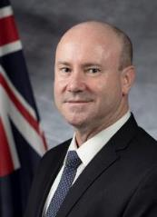 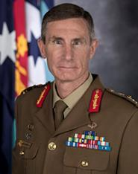

Chief of Navy Chief of Army Chief of Air Force

Vice Admiral Lieutenant General Air Marshal

Michael Noonan Rick Burr Mel Hupfeld

AO, RAN AO, DSC, MVO AO, DSC

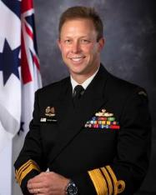 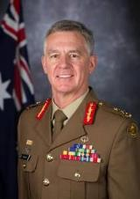 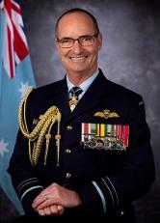

## Defence Culture

* Pray that Defence culture would be based on Christian values.
* Pray that the ADF continues to monitor Defence members’ behaviour against these values with accountability for their actions.
* Pray that those who have been adversely affected by poor behaviour in the military will find support and closure.

## Training Settings

* Pray for instructional staff, students and families.
* Pray for wisdom to deal with difficult situations.
* Pray that Christian military ministries and Chaplains operating with the training institutions will be successful in bringing the word of God to the trainees.
* Pray that the trainees will be open to hearing the gospel and acting on it.

# Prayer Focus 4:

### Defence Christian Ministries

* Pray for cooperative unity between the ministries.
* For Godly wisdom, direction and leadership.
* For resources to provide capacity to implement ministry plans.
* Pray for the organisation of the next Defence Christians’ Dinners in Canberra, Melbourne, Darwin and possible other locations.

Association for Christian Conferences, Teaching and Service (ACCTS)

* Pray for those involved in ACCTS as they seek to support military Christian leaders to form and develop locally-led Military Christian Fellowships around the world.
* Pray for those who are considering replacing Russell and Helen Bielenberg in continuing this ministry in our region.

Association of Military Christian Fellowships (AMCF)

* Pray AMCF SW Pacific Region Vice President, LTCOL Jamie van Heel, that he would have Godly wisdom in this role.
* Pray for wisdom and protection for Jamie and others as they prepare for and visit Tonga in May. Pray the visit bears much fruit.
* Pray that many leaders will be raised up in the SW Pacific Region to run small groups and spread the word of God through their military, police and security forces.

Everyman’s Welfare Services

* Pray for God’s favour and protection on the Everyman’s Reps as they get alongside servicemen and women in their Rec Centres, in the field on exercise and on overseas deployment, sharing the Gospel message.
* Pray for financial gifts to continue to flow and increase for the Ministry and for ongoing good stewardship as we update our fleet of vehicles one at a time.

FOCUS Military Ministry

* Pray as FMM workers keep focussed on making Christ known to the young men & women entering the ADF.
* Pray as they honour Christ by their lives & doctrine.

Military Christian Fellowship

* Pray for the right person to put themselves forward for any upcoming MCF-A Exec, Council or other committee positions. Pray that more people will come forward to be MCF Reps and lead groups at Defence locations across Australia. Thank God for firm and faithful servants who have volunteered in all these roles in the past.
* Pray for the new MCF-A Vice Chair, CAPT(Army) Jacob Choi and for the newly formed MCF Constitution Review Committee. Pray the Committee will be able to provide sound recommendations to the AGM that honour God and enable MCF to more effectively build His Kingdom in the ADO, and that this will be well received by MCF members.

Navigators’ Military Ministry

* We ask for more labourers into the ADF harvest field (Mt 9:35-38)
* We ask for protection for marriages within the ADF, and that they would be Christ centred and loving.
* We ask that workers in the harvest would have a generational mindset (passing on what has been learnt) 2 Tim 2:2 and ask God for many to hear the word, believe and obey.

Red Shield Defence Services

* Please pray that the resources that are needed as we seek to expand our footprint across Defence will be provided at just the right time.
* Please pray that the RSDS practical ministry in supporting members will be something that not only speaks of the love of Jesus, but shows Defence members that they are deeply loved by God.
* Pray that the "brew with the listening ear" that RSDS brings whether on base, exercise or deployment will encourage members in their journey of faith.

Solid Rock Ministries

* Praise God for the many Solid Rock groups that meet around Australia.
* Pray that women would be encouraged in their walk with Jesus and continue in community.
* Thank you Lord for the provision of a community centre for Solid Rock. A great place to invite women into and show them how much they are loved and cared for.

# Prayer Focus 5:

### Local Needs

* Pray that people in isolation would know God’s grace and truth and be comforted in this difficult time.
* Pray that God’s church in this nation would rise to the occasion in being the church despite the current restrictions on our personal bodily meeting together.
* Pray that the impacts on people affected by the social distancing measures put in place by the government would be minimised through the thoughtful, practical care of God’s people, by God’s grace.

# Prayer For Defence Reconciliation

Lord, we thank you that you have great plans and purposes for the Australian Defence Organisation.

We are sorry that there have been occasions where we as Defence members, past and present, may have not appropriately exercised our responsibilities and have caused physical, mental and spiritual injuries to Defence members. Additionally, our culture has been tolerant of some of these actions. These actions have served Defence poorly, hurting our people and damaging our reputation. We admit our shortfalls and seek your wisdom Lord Jesus and acknowledge that it is only through your atoning sacrifice at Calvary and the blood that you shed, that our sins can be forgiven.

We want to be in alignment with your will. We thank you that through taking hold of your victory at Calvary we can trust your word that you will purify us of from all unrighteousness as we have confessed our sin before you. We desire to learn your ways. By faith with your leading and guidance we will be able to deal with the past and move forward into your will for us. We thank you for the strength that comes from our Godly heritage and we desire to take on the values of your kingdom culture of right honour, respect and truth.

Lord, give our senior leadership your wisdom to implement changes to our culture that conform to your will, and give our Defence members the right attitude to change aspects of our culture that are not becoming to you and our professional Defence organisation. We commit our Defence organisation into your hands and pray that righteous men and women will lead it to fulfil the purposes and plans that you have for our Defence organisation and our nation.

In Jesus name. Amen

by LTCOL Jamie Van Heel (April 2012)

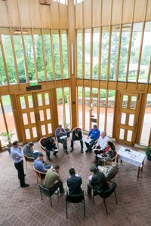

National Day of Prayer for Defence

Sponsored by Military Christian Fellowship of Australia

<http://www.mcf-a.org.au/>

Building the Kingdom of God in the ADF

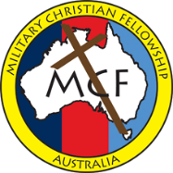

1. A Prayer Book for Australia, 1999, the Anglican Church of Australia, Broughton Books, Mulgrave, Vic, p. 591.
2. [*http://www.defence.gov.au/operations*](http://www.defence.gov.au/operations)